

**Mitolyn Buy Direct official secure Website**

**What is Mitolyn?**

[Mitolyn](https://github.com/mitolyn-discount-buy-official-website) is a premium herbal weight loss supplement designed to help individuals achieve their weight loss goals naturally. Crafted with plant-based ingredients, Mitolyn supports the body’s natural processes to promote effective fat burning and energy enhancement. This supplement is backed by research and formulated to target mitochondrial health, the powerhouse of our cells, ensuring a boost in metabolism while maintaining overall wellness.

**🟩** [**Mitolyn Buy direct official secure Website**](https://buy-mitolyn.site/)

**🟩** [**Mitolyn Buy direct official secure Website**](https://buy-mitolyn.site/)

Manufactured under strict quality standards, Mitolyn is made in FDA-approved facilities in the USA, ensuring safety and purity. Free from artificial additives and harmful chemicals, this natural weight loss solution provides an effective way to support your weight loss journey. If you’re looking for a trusted product, you can always [buy Mitolyn from the official secure source](https://buy-mitolyn.site/) for peace of mind and authenticity.

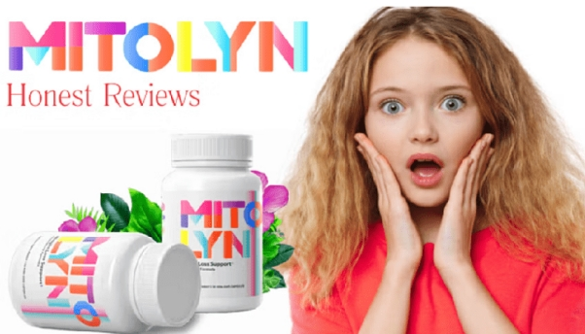

**How Does Mitolyn Work?**

Mitolyn works by targeting the body’s core mechanisms for weight loss. One key function of Mitolyn is its ability to boost metabolism, helping the body convert stored fat into energy more efficiently. By enhancing mitochondrial health, it ensures your cells are working at peak performance, promoting energy enhancement throughout the day. This steady energy flow helps you stay active, burn more calories, and lose weight effectively.

In addition to boosting metabolism, Mitolyn helps with appetite control by naturally curbing hunger cravings. The supplement also addresses stress reduction, a common barrier to weight loss, by including ingredients that support cortisol regulation. Furthermore, its blend of digestive support compounds ensures proper nutrient absorption, which plays a critical role in maintaining a healthy weight.

**How Mitolyn Helps with Weight Loss**

Mitolyn’s unique formulation combines a variety of natural ingredients, each with specific benefits for weight loss. Here are some of the key ingredients and their roles:

**Key Ingredients in Mitolyn**

* Green Tea Extract: Packed with antioxidants, this ingredient boosts metabolism and promotes fat oxidation, making it easier for the body to burn stored fat. It also provides natural energy enhancement, so you can stay active throughout the day.
* Garcinia Cambogia: A well-known natural appetite suppressant, Garcinia Cambogia helps reduce cravings and prevents the body from storing excess fat.
* Ashwagandha: This adaptogenic herb reduces cortisol levels, which can help decrease stress-related weight gain and emotional eating.
* L-Carnitine: Known for its role in energy production, L-Carnitine helps the body convert fat into usable energy, aiding in effective fat loss.

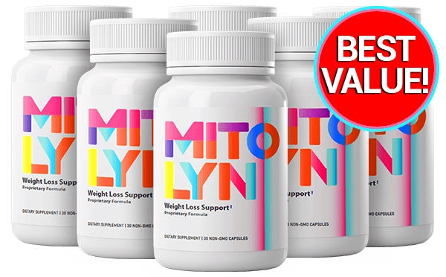

Other notable ingredients include Chromium Picolinate for blood sugar regulation, Black Pepper Extract for enhanced absorption of nutrients, and Apple Cider Vinegar for improved digestion and fat metabolism. Together, these ingredients work synergistically to promote [Mitolyn natural weight loss](https://sites.google.com/view/buy-mitolyn-official-website/home) and long-term health.

**Mitolyn Frequently Asked Questions**

**Will I be charged any additional fees?**

No, you can rest assured that this is a one-time payment. You will not be burdened with any additional charges, subscription fees, or hidden costs of any kind. ✅ [**Mitolyn Buy Direct official secure**](https://github.com/mitolyn-discount-buy-official-website)

**How safe is Mitolyn?**

Mitolyn is considered a legitimate supplement and is designed with safety in mind. Its formulation uses natural and plant-based ingredients that complement the body’s natural processes. The absence of artificial additives ensures reduced risk of side effects, making it a safe choice for most individuals.

**Can I use it with other supplements?**

Yes, Mitolyn can generally be used with other supplements. However, you should avoid combining it with products that have overlapping ingredients, as this may lead to excess intake of certain compounds.

How long will it take to see results?

Results may vary depending on the individual, but many users report noticeable changes within 2 to 4 weeks of consistent use. For best results, combine Mitolyn with a balanced diet and regular exercise.

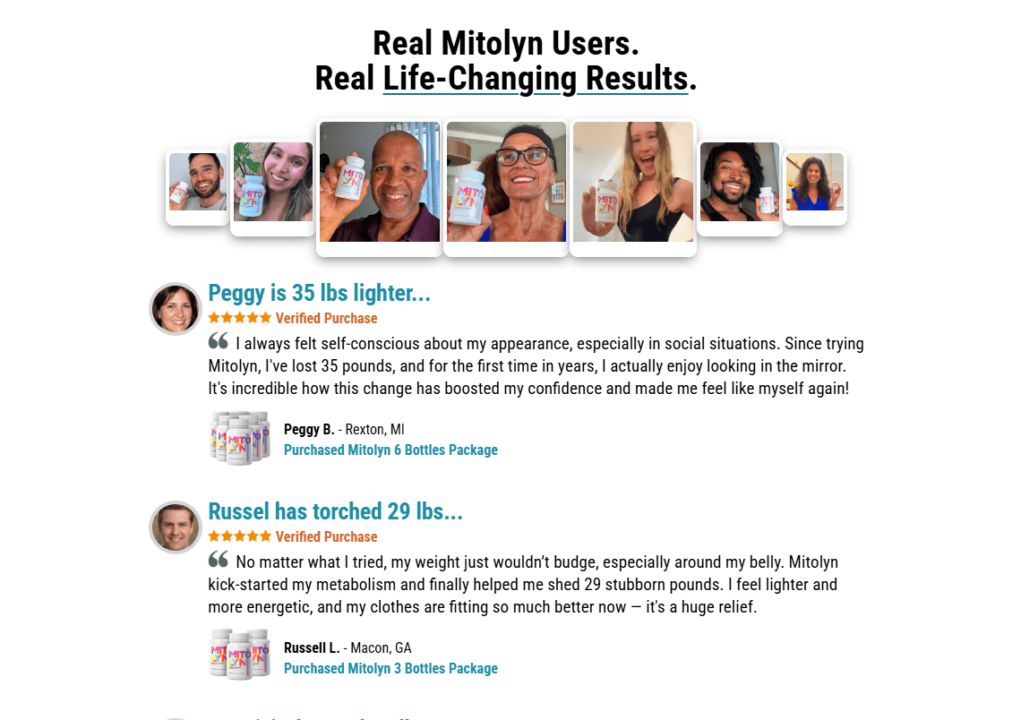

**Is Mitolyn suitable for all diets?**

Yes, Mitolyn is free from common allergens like gluten, dairy, and soy, making it suitable for most dietary preferences, including vegan and vegetarian lifestyles.

Benefits of Mitolyn

1. Boosts metabolism for effective fat burning.
2. Enhances energy levels to keep you active throughout the day.
3. Suppresses appetite, reducing hunger cravings.
4. Promotes better digestion and nutrient absorption.
5. Supports mitochondrial health for overall cellular wellness.
6. Reduces stress-related weight gain by managing cortisol levels.
7. Made from natural, plant-based ingredients.
8. Free from harmful chemicals and artificial additives.
9. Manufactured in FDA-approved facilities in the USA.
10. Backed by a 60-day money-back guarantee for peace of mind.

**Does** [**Mitolyn**](https://buy-mitolyn.site/) **Have a Money-Back Guarantee?**

Mitolyn comes with a 60-DAYS 100% MONEY BACK GUARANTEE. You can test the supplement for two months, and if you’re among the rare 0.5% who aren’t satisfied, you’re eligible for a full refund. Consider it a risk-free trial run to see if Mitolyn works for you. If it doesn’t meet your expectations, simply contact customer support to initiate the refund process.

✅ [**Buy** **Mitolyn Direct official secure**](https://buy-mitolyn.site/)

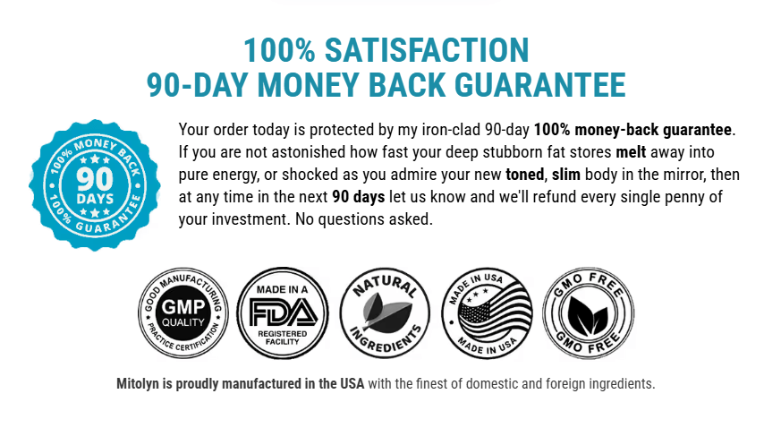

Real Mitolyn Reviews from Customers

⭐⭐⭐⭐⭐ *"Finally, a Supplement That Works!"*

Jessica T., Los Angeles, CA

I’ve tried countless supplements, but none worked as well as Mitolyn. Within a month, I started noticing a difference—my energy levels skyrocketed, and my clothes fit better. It curbed my cravings, and I didn’t feel like I was on a restrictive diet. I love that it’s made from natural ingredients, and I’ve had no side effects. Highly recommend it to anyone serious about losing weight.

⭐⭐⭐⭐⭐ *"Amazing Energy Boost!"*

Amanda S., New York, NY

[Mitolyn reviews](https://github.com/Mitolyn-Official-Site-Buy-Direct-Secure) has been a game-changer for me. I was skeptical at first, but I decided to give it a shot. Not only did it help me lose weight, but it also gave me the energy to get through my busy days without crashing. I’ve already recommended it to my friends. The best part? It’s affordable, and the results speak for themselves.

⭐⭐⭐⭐ *"Great for Stress and Weight Loss!"*

**Mike R., Dallas, TX**

As someone who struggles with stress-related weight gain, Mitolyn has been a lifesaver. It’s helped me manage my cravings and keeps me feeling energized all day. I’ve lost 12 pounds in two months without making major changes to my diet. The fact that it’s natural and free of artificial additives makes it even better. I’m so glad I found it.

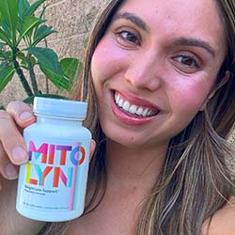 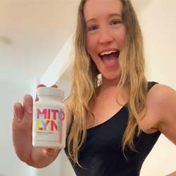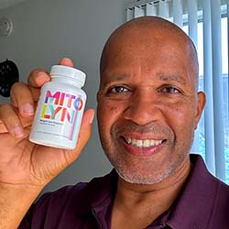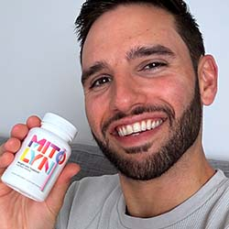

✅[Mitolyn Official Website](https://buy-mitolyn.site/)

✅[Mitolyn natural weight loss](https://buy-mitolyn.site/)

✅[Mitolyn Buy Direct from the Official Secure Source: Boost Your Weight Loss](https://buy-mitolyn.site/)

[Mitolyn](https://buy-mitolyn.site/)